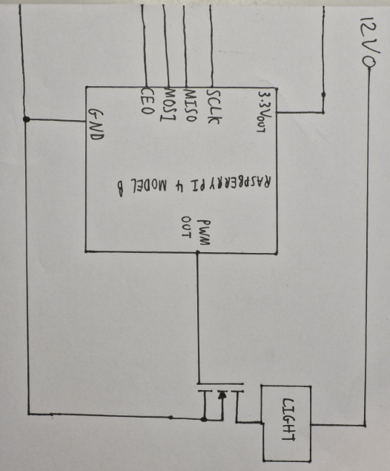
I am joining the grounds, or 0V power rails, of the Raspberry Pi and the circuit with the light output and the 12V supply so that the MOSFET input is not left floating relative to the rest of the circuit. In other words, if the input to the MOSFET does not have the same 0V reference as the MOSFET itself, the MOSFET will not be able to determine the voltage input into it due to a lack of a reference voltage.
I am using a 12V supply to power the light output of our circuit. The Raspberry Pi cannot provide enough current to light the lamp and so an external power source is needed.
This transistor, an N-Channel MOSFET, is needed as the Raspberry Pi outputs source far too low amounts of current compared to the current needed for the lamp to light. The transistor is a power amplifier, allowing the lamp to light when the Pi PWM output is high.
This is the light output of our circuit. Its brightness will vary according the brightness of the surroundings via PWM.
The PWM Output is the GPIO port that outputs a square wave with different duty cycles which will vary the average brightness of the lamp accordingly.

